**Single sign-on (SSO)**

The Single Sign-On process that enables Regional Business Manager (RBM) and Area Business Manager (ABM) to access their accounts without the need to provide credentials. This efficient and secure method streamlines the login process, enhancing user experience.

Store Manager (SM) cannot login through this SSO

**Process Overview:**

The SSO process is designed to simplify and secure the login experience for RBMs and ABMs when accessing their accounts. It eliminates the need for manual credential input by following these steps:

**Step 1: Access the Email**

Start by opening your email client.

**Step 2: Select a Relevant Email**

From your inbox, identify and select an email containing the SSO login link.

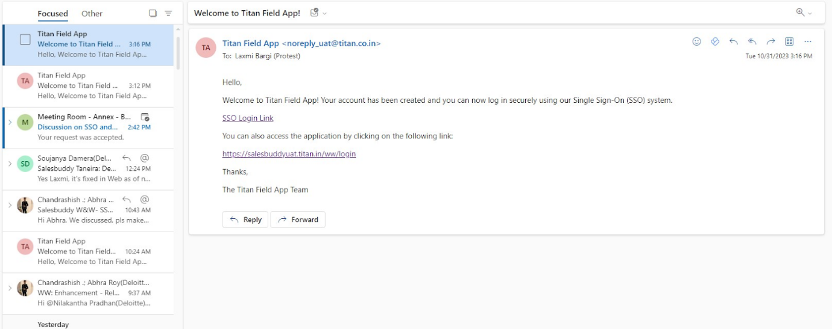

**Step 3: Click on SSO Login Link**

Click on the provided SSO login link within the selected email. This link directs you to the SSO login.



SSO login link for RBM and ABM



**Step 4: Recognizing Previous Users**

If you have previously used the SSO process, you will be automatically recognized, and further steps are not necessary. You will be redirected to the SalesBuddy website.

or else you can directly go to <https://salesbuddyuat.titan.in/ww/>

**Step 5: Role Selection**

If you are a first-time user or not recognized, you will be prompted to select your role, either RBM or ABM, from the available options.

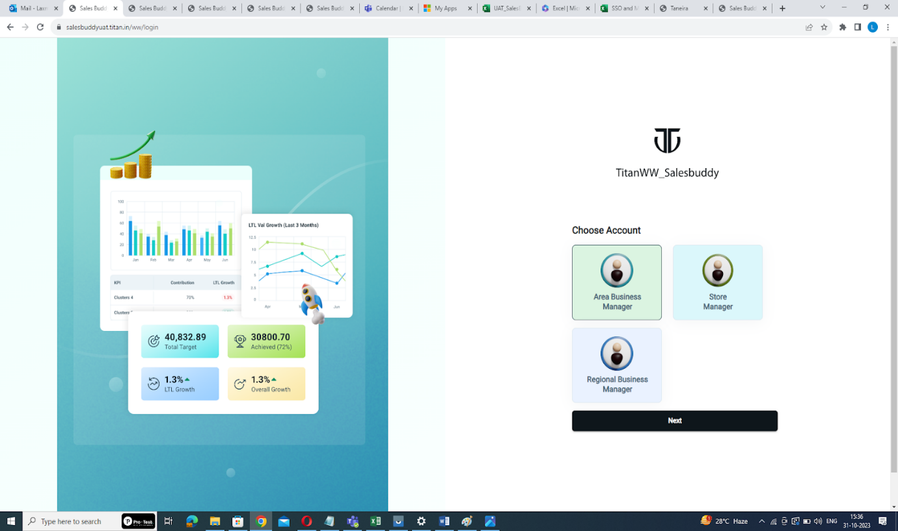

Select your role

**Step 6:** **Click "Next"**

After selecting your role, click the "Next" button to proceed.



Click here

**Step 7: Direct Access to the Main Page**

Following successful role selection, you will be automatically redirected to the main page specific to your role without the need for further authentication.

By following these steps, the SSO process ensures that RBMs and ABMs can access their accounts efficiently, secure and hassle-free way to access your accounts, enhancing their user experience and ensuring data security.